**4 bit**

**DEPARTMENT OF COMPUTER SCIENCE**





**SOFTWARE REQUIREMENT SPECIFICATION**

**“HOME CALLING”**

**Guided by Submitted by**

**Dr. Mainaz Faridi Komal choudhary**

**Rakshita sharma**

**Shambhawi kumari**

**Saumya**

**TABLE OF CONTENTS**

**1. Introduction**

**1.1 Purpose**

**1.2 Scope**

**2. General Description**

**2.1 Product Perspective**

**2.1.1 Product Function**

**2.1.2 Hardware Interface**

**2.1.3 Software Interface**

**2.1.4 Communication Interface**

**2.2 User Characteristics**

**2.3 Technologies used**

**3. Specific Requirements**

**3.1 Functional Requirements**

**3.2 Non-Functional Requirements**

**3.2.1 AVAILABILITY**

**3.2.2 SECURITY**

**3.2.3 RELIABILITY**

**3.2.4 PORTABILITY**

**3.2.5 MAINTAINABILITY**

**1. Introduction**

**1.1 Purpose**

The document focuses on describing the software requirements of project, a website for generating home going journey plans for Banasthalites.This project would be carried out to meet the software development requirement of home calling . the document focuses on all the functional and non functional performance and security requirements of the project

**1.2 Scope**

Our software product will be named as home calling and it will be a website which will provide home journey to bansathalites. it will give the information and booking links of the needed transport system like bus . It will also provide meals connectivity between two people of same destination.

**2. Overall description**

**2.1 Product perspective**

Home calling is to provide a safe and secure journey to the girls of Banasthali. With this, we will try to provide confusion and fraud-free journeys. Being a Banasthalite we all face some kind of issues at the time of going home many times we got scammed by the girls. who claimed that they are booking agents of buses and after getting the money they get vanished so our website will provide them with authorized information about transport systems like buses from Banasthali to their destination. It will also provide the option of meals and connectivity here connectivity means two or more girls from the same destination can connect.

**2.2General description**

**2.2.1 Hardware Interface**

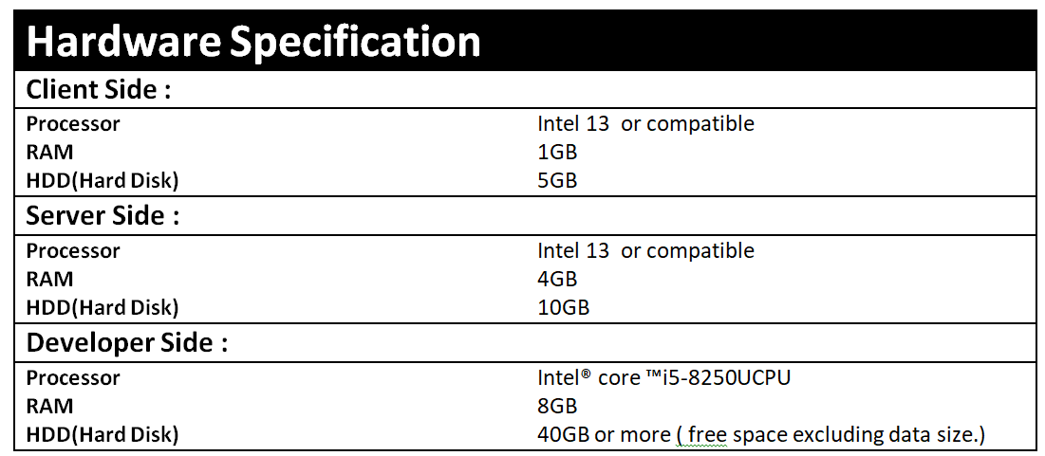

**2.2.2 Software Interfaces**

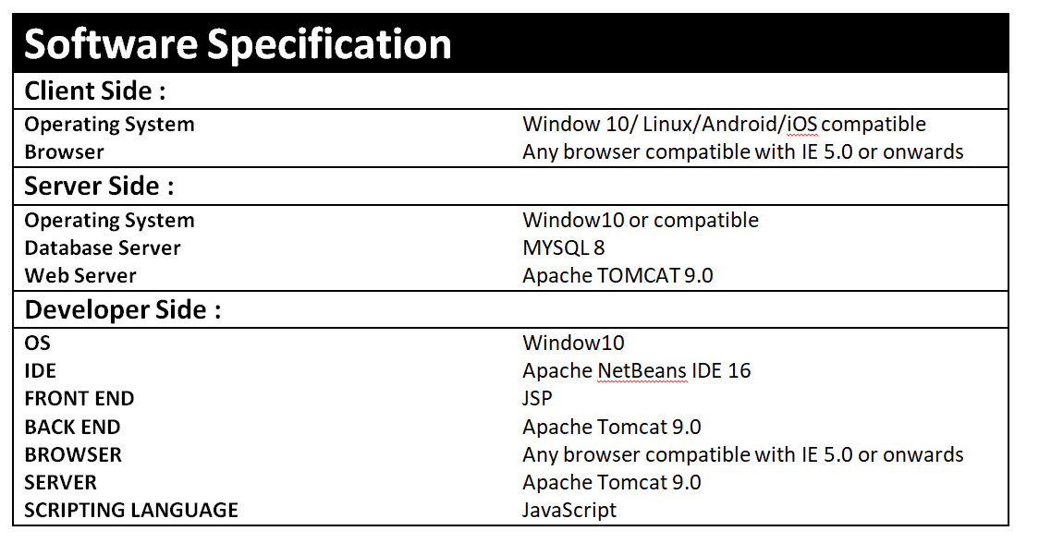

**2.2.3 Communication Interface**

1. Servers on the Internet will be using the HTTP/HTTPS protocol.

2. Clients on Intranet will be using TCP/IP protocol.

**2.3User Characteristics**

The user must be familiar with GUI components.

1. Admin: The head of the database. Only he

can make changes like deleting users, managing buses, availability of food, and also can manage connectivity of two or more travel mates. He should be well-versed in using the system and should be known about the

Database.

2. Student: In both the case of the individual and the

group participant, we assume the students are computer literate, well

aware of English, have a valid ID, and also type in the right kind

of data

3. Restaurant: We assume that the restaurant admin must be English literate and have good knowledge of technology with 24/7 net connectivity.

**2.4 Assumptions and Dependencies:**

1)Students can log in with their respective Smart Card ID and

password.

2) Internet facilities should available all the time.

3) Delivery charge will be free for food.

4) Transaction would be applicable through credit/debit card or UPI.

**2.5 Technologies to be used**

Front End: HTML,CSS,Javascript

IDE : Netbeans

Technology : JSP/Servlet

**3.1 Functional Requirements**

The application shall have the following functional requirements:

➢ Booking Module

➢ Create a destination

➢ Save destination

➢ Update destination info

➢ List destination

➢ Connect two people

➢Food booking

**3.1.2 Register a profile**

➢ Users have the option to register a profile with **Home Calling** from menu bar.

2. Select “Register” from the landing page, and follow the prompts to fill out and complete the registration.

a. Information will be stored on the database so the website can allow customers to

plan/save/edit/delete trips in the future.

**3.1.3 Login to profile (edit, plan, view saved trips)**

1. From the homepage, users, once registered, can login to their profile to

a) plan a destination

b) edit their profile details

c) view, edit, or cancel any saved destination.

**3.1.4. Planning a trip**

1. Students will be able to save the destination.

2. Students fill in the required information, such as their source and destination, meal preferences, time preferences, and the number of people they are traveling with.

3. Students can modify (change/delete/add) the suggested trip option.

**3.1.4. Logout to Profile**

1. Logout from the profile.

**Use cases**

**Use case 1- ADMIN**

**USE CASE TABLE FOR ADMIN**

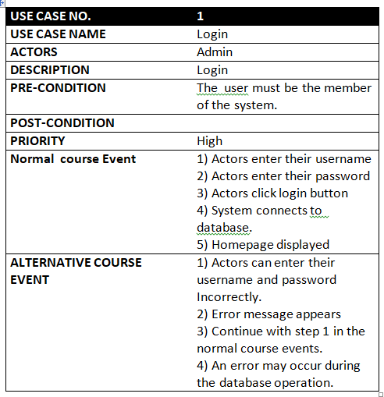

**USE CASE TABLE FOR STUDENT**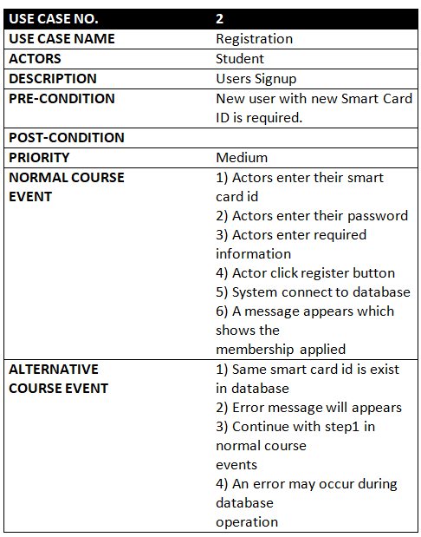

**USE CASE TABLE FOR RESTAURANT**

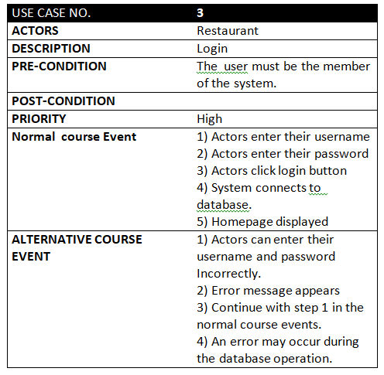

**Use case diagram**

1. **Use case diagram for Admin**

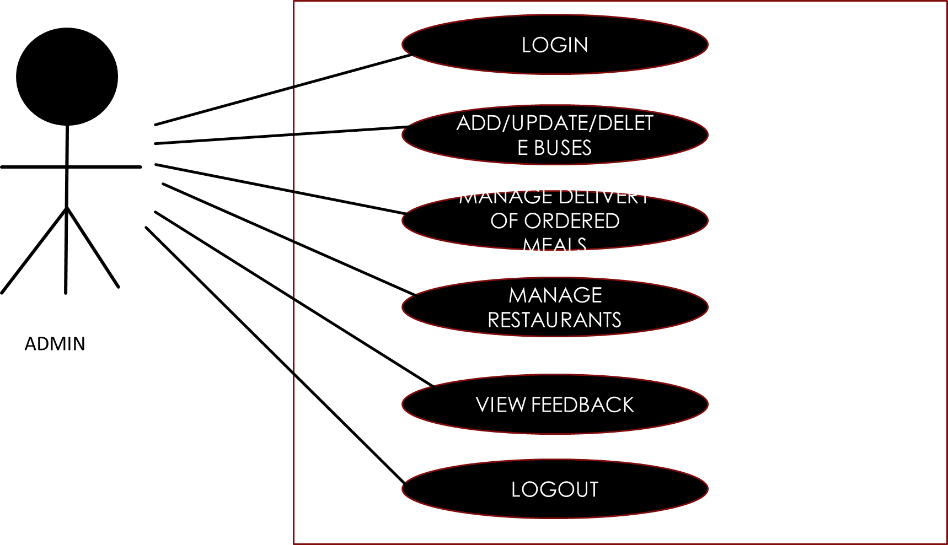

1. **Use case diagram for Student**

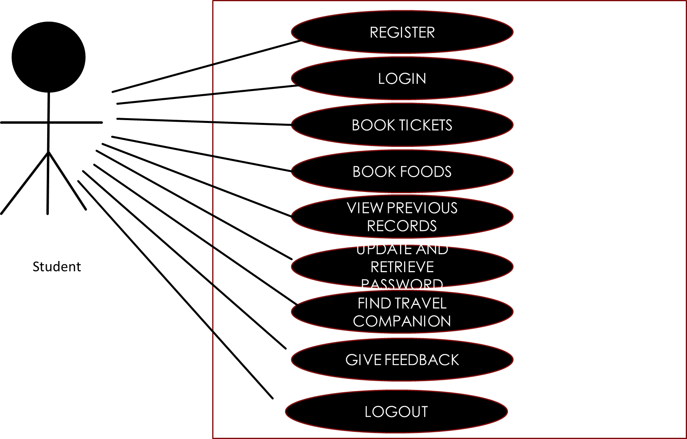

**3.Use case diagram for restaurant**

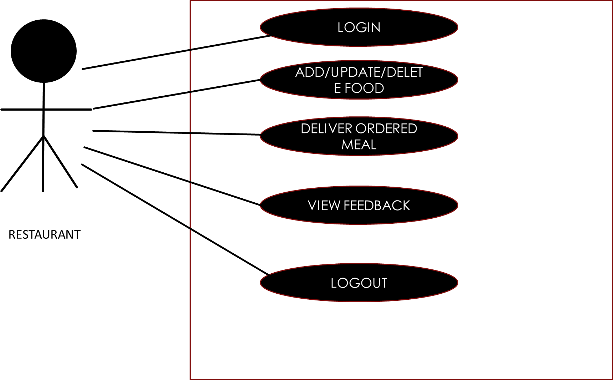

**3.2 *Non functional Requirements(Software System Attributes)***

**Software System Attributes**

There are a number of quality attributes of software that can serve as requirements. It is important that required attributes be specified so that their achievement can be objectively verified.

**RELIABILITY**

All the information provided by the website Home Calling is reliable.

**AVAILABILITY**

The availability of the website Home Calling depends upon the internet connection of the client. Since this is a client server-based website, the website will be available all the time. Students should have an account to access all the features of the website and in case, she is unregistered they should sign up to the system. Moreover, before signing up the guest students can browse through the website.

**SECURITY**

The authorization mechanism of the system will block the unwanted attempts to the server and also let the system decide which privileges the students possess. The system has different types of students (Admin and Students), so there are different levels of authorization. The system has different modules which have been assigned certain functions, thus providing data abstraction and encapsulation.

**MAINTAINABILITY**

The requirements and modules that are explained in this document are enough to satisfy the student needs and requirements. The maintainability shall be easily done by integrating new modules and updating the existing modules at specific intervals of times.

**FLEXIBILITY**

Website can be used by different actors in their own manner. For the developers and designing team, the operational program can be modified and debugged so as to provide enhancements in the website.

**PORTABILITY**

The Home Calling website is an online service created in a HTML framework and thus can easily be accessed by all.

**SDS**

**DEPARTMENT OF COMPUTER SCIENCE**





**SOFTWARE DESIGN SPECIFICATION**

**“HOME CALLING”**

**Guided by Submitted by**

**Dr. Mainaz Faridi Komal choudhary**

**Rakshita sharma**

**Shambhawi kumari**

**Saumya**

**TABLE OF CONTENTS**

**1. Introduction**

**1.1 Purpose**

**1.2 Scope**

**2. System Architectural Design**

**2.1 High Level Design**

**2.2 Detailed Description of Components**

**2.2.1 Structure Chart**

**2.2.2 Data Flow Diagram**

**3. Data Design**

**3.1 Database Description**

**3.2 E-R Diagram**

**4 User Interface Design**

**4.1Detailed Description of Components**

**4.2 Screen images**

**5. TYPES OF TESTS (With Implementation)**

**6. Appendices**

**7. References**

**1. Introduction**

System Design Specification tells us how our software is

going to built. It includes various diagrams to show the

entire database and relationship among all database tables.

The project “HOME CALLING” tries to giving experience of confusion free fraud free journey to home at the time of holidays and casual leave. As the name suggests this projects provides the information of all routes ,available seats in buses ,foods from your favorite canteen at your seat and connecting two peoples of same destinaton. Our project is one-step solution for all journey related problems. The software allows the sculpting of the database based on the requirement of the Banasthalite(who is willing to go home) and then provides all things according to their convenience and our availability.

**1.1 Purpose**

1. To develop a software for managing journeys of Banasthalites.It is a powerful and user friendly online service tool.

2. The software will computerise the existing journey style. The existing journey style has lots of confusion and fraud

## **1.2 Scope**

Our software product will be named as home calling.and it will be a website which will provide home journey to Bansathalites it will give the information and booking links of the needed transport system. It will provide meals.

**2.2- Component Interface Description**

**Admin**

I/P- Login and password

O/P- Logged in, admin can handle all the D/B updating .He can

add new buses/restaurant , announce the important dates, declare vacant seats , and view the feedback of the students regarding

buses / food.

**Registration**

I/P- Student name, smart card ID, password, course, their field

of interest, email id, contact no.

O/P- Student gets registered .

**Vacant Seat**

I/P- Click on particular Bus for which you want to get

information.

O/P- Information displayed.

**Booking**

I/P- Click on particular results item (book seat)

O/P:-The desired can book and see the detailed information

Regarding the bus.

**Connect to people**

I/P- Click the destination and connected with your travel mates.

O/P- Connected to the travelmate.

**Dates and Announcements**

I/P- Click on particular date.

O/P- Information regarding the scheduling of the different

Vehicles , food , people and the like are displayed.

**Food**

I/P - Click on your order.

O/P - Information regarding the menu displayed.

**3. High Level Design**

High-level design (HLD) explains the architecture that would be used for developing a software product. The architecture diagram provides an overview of an entire system, identifying the main components that would be developed for the product and their interfaces. The HLD uses possibly nontechnical to mildly technical terms that should be understandable to the administrators of the system.

**ER Diagram**

An entity–relationship model (or ER model) describes interrelated things of interest in a specific domain of knowledge. A basic ER model is composed of entity types (which classify the things of interest) and specifies relationships that can exist between entities (instances of those entity types).

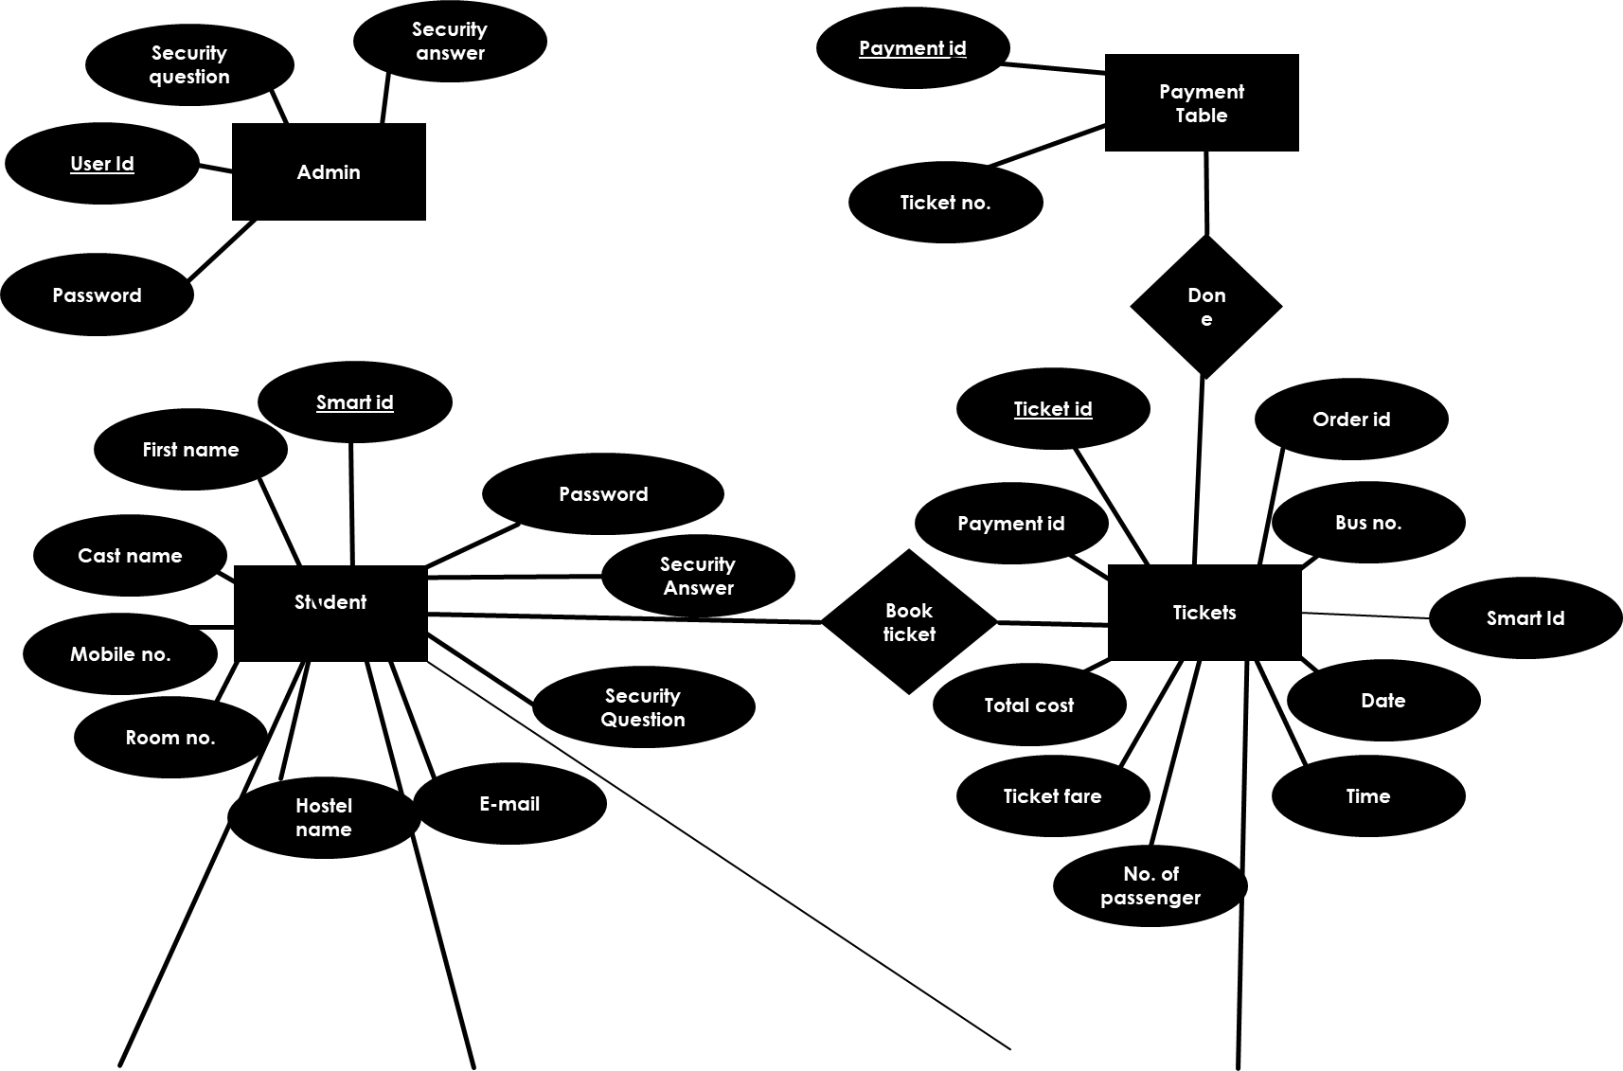

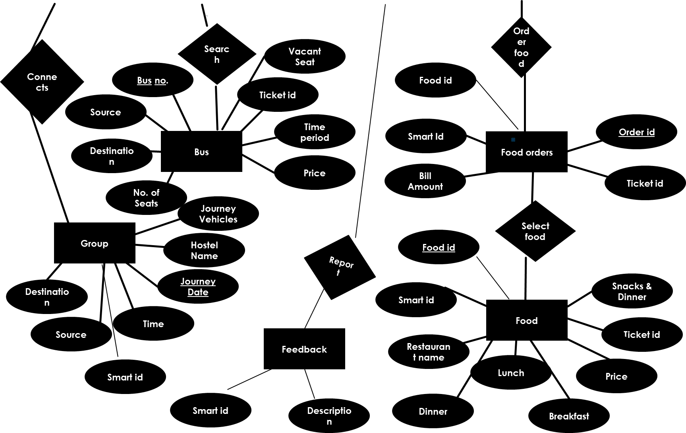

**Data Design**

Description:

i. In this we include, maintain & format the whole Database and its tables.

ii. The tables corresponding to each of the entity, holding the information about them are designed.

iii. The tables have the fields, their description, and their data type as well as integrity constraint.

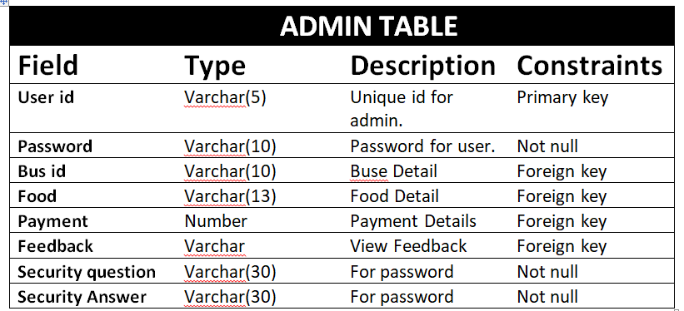

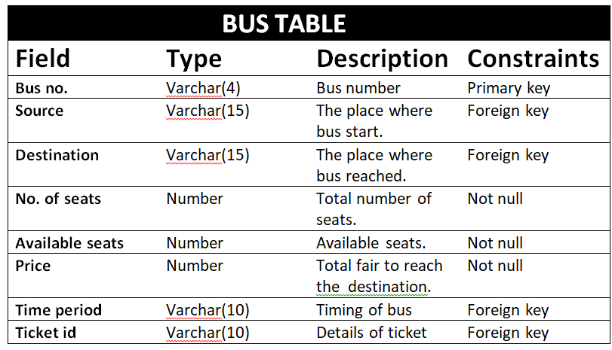

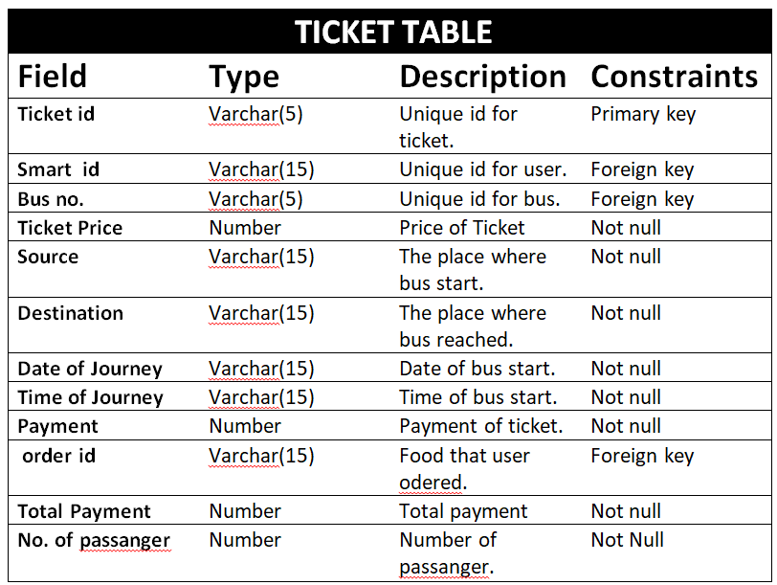

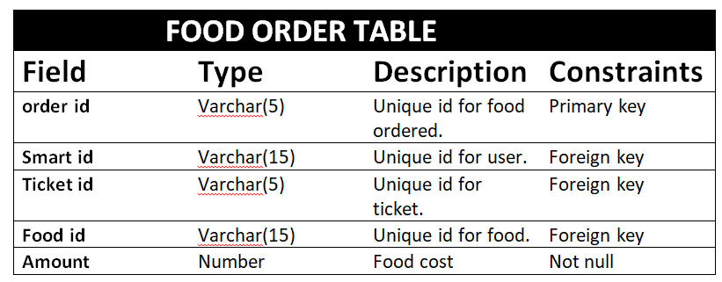

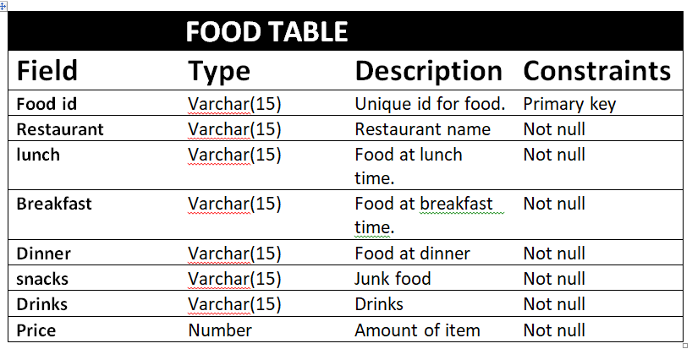

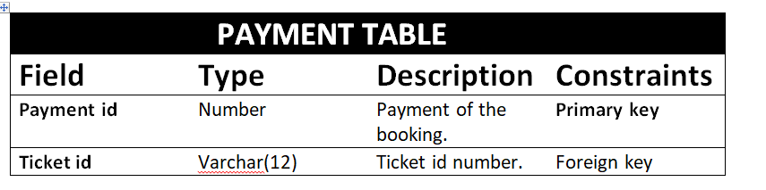

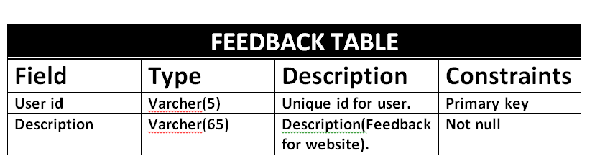

**Data Flow Diagram**

A data-flow diagram is a way of representing a flow of a data of a process or a system (usually an information system). The DFD also provides information about the outputs and inputs of each entity and the process itself. A data-flow diagram has no control flow, there are no decision rules and no loops**.**

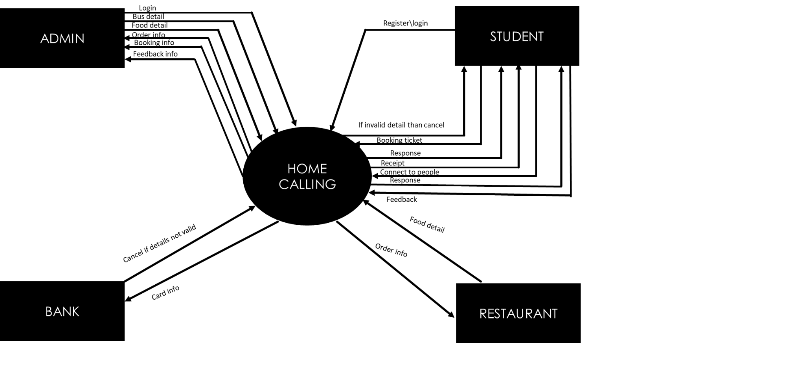

**DFD LEVEL 0**

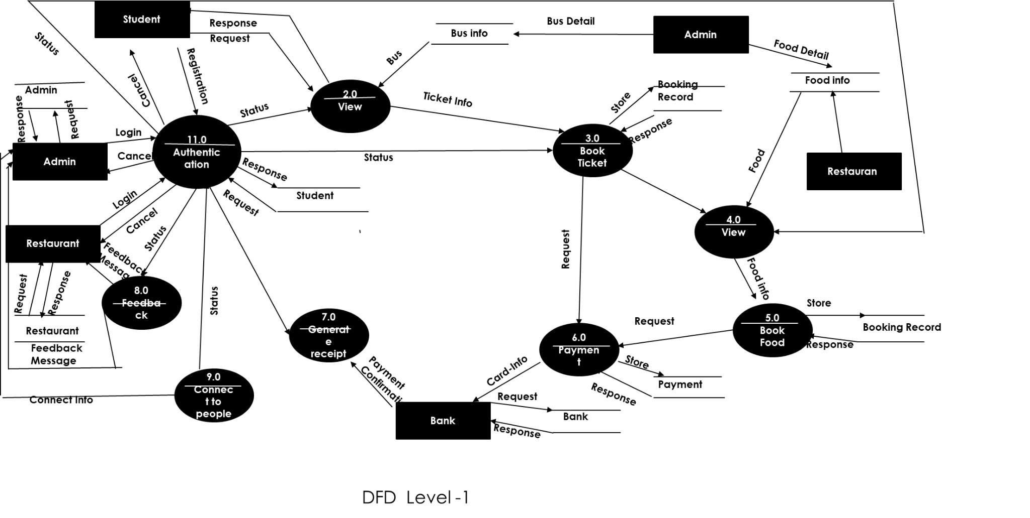

**Flowchart**

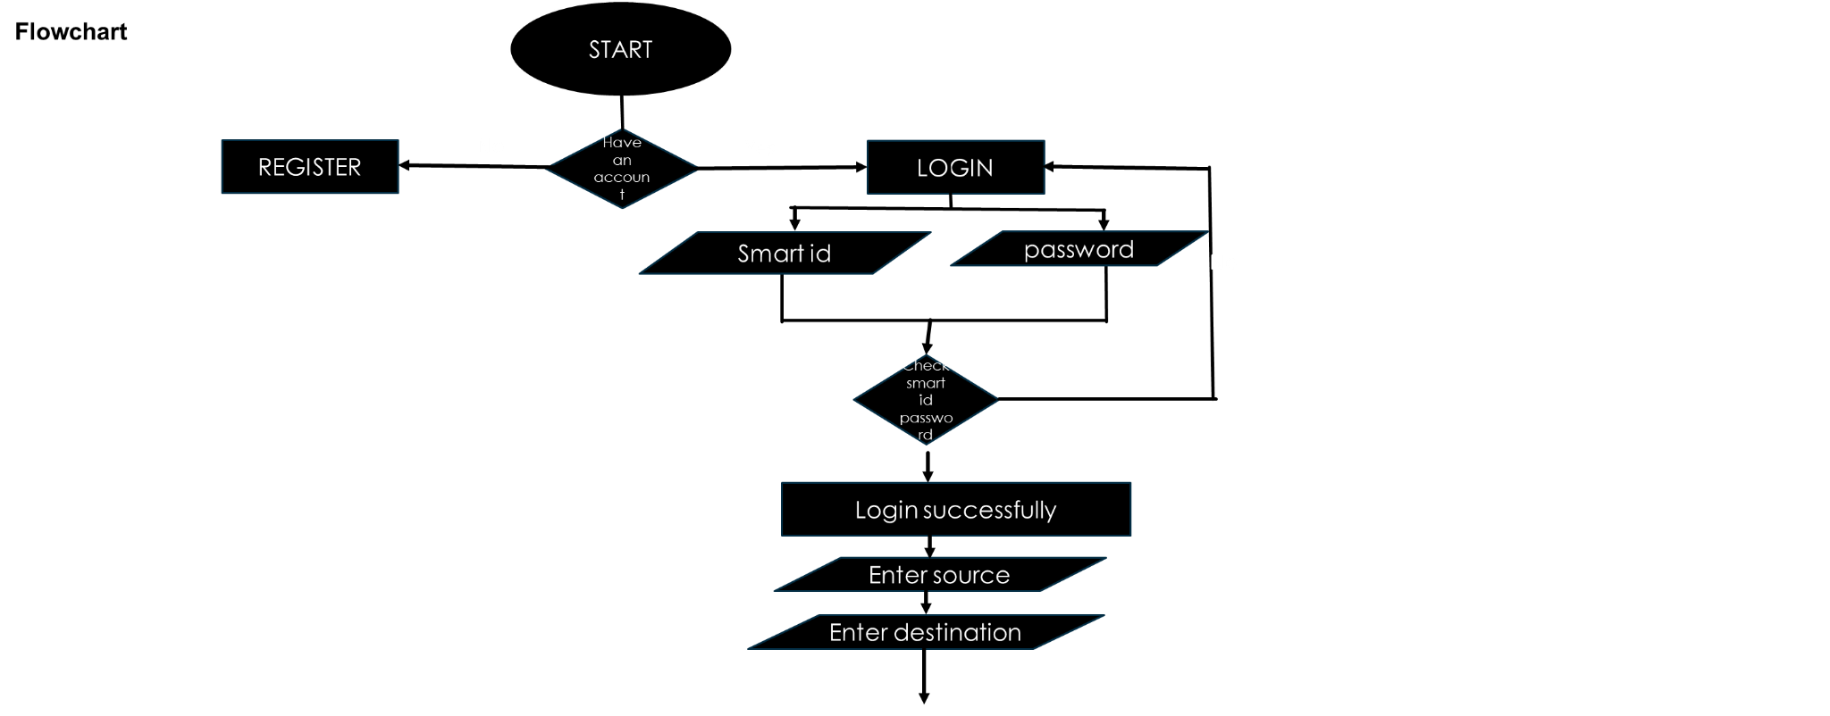

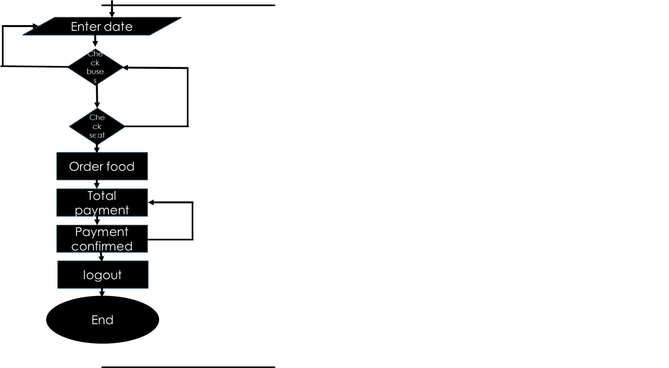

**TESTING**

Software testing can be stated as the process of validating ad verifying that a software program/ application/ product:

1. Meets the requirements that guided its design and development;

2. Works as expected; and

3. Can be implemented with the same characteristics.

Testing is the process of making sure that the program performs the intended tasks.

**1. Unit Testing:**. Each component or part of the system is tested individually.

**2. Module Testing:** A collection of dependent components such as an object class, procedures and functions are tested in this testing.

**3.Integration Testing:** In this, many units tested modules are combined into sub systems, which are then tested.

**4. System Testing:** Entire system software is tested. It is a testing of the system against its initial objectives.

**Screen Image**

**Home page**

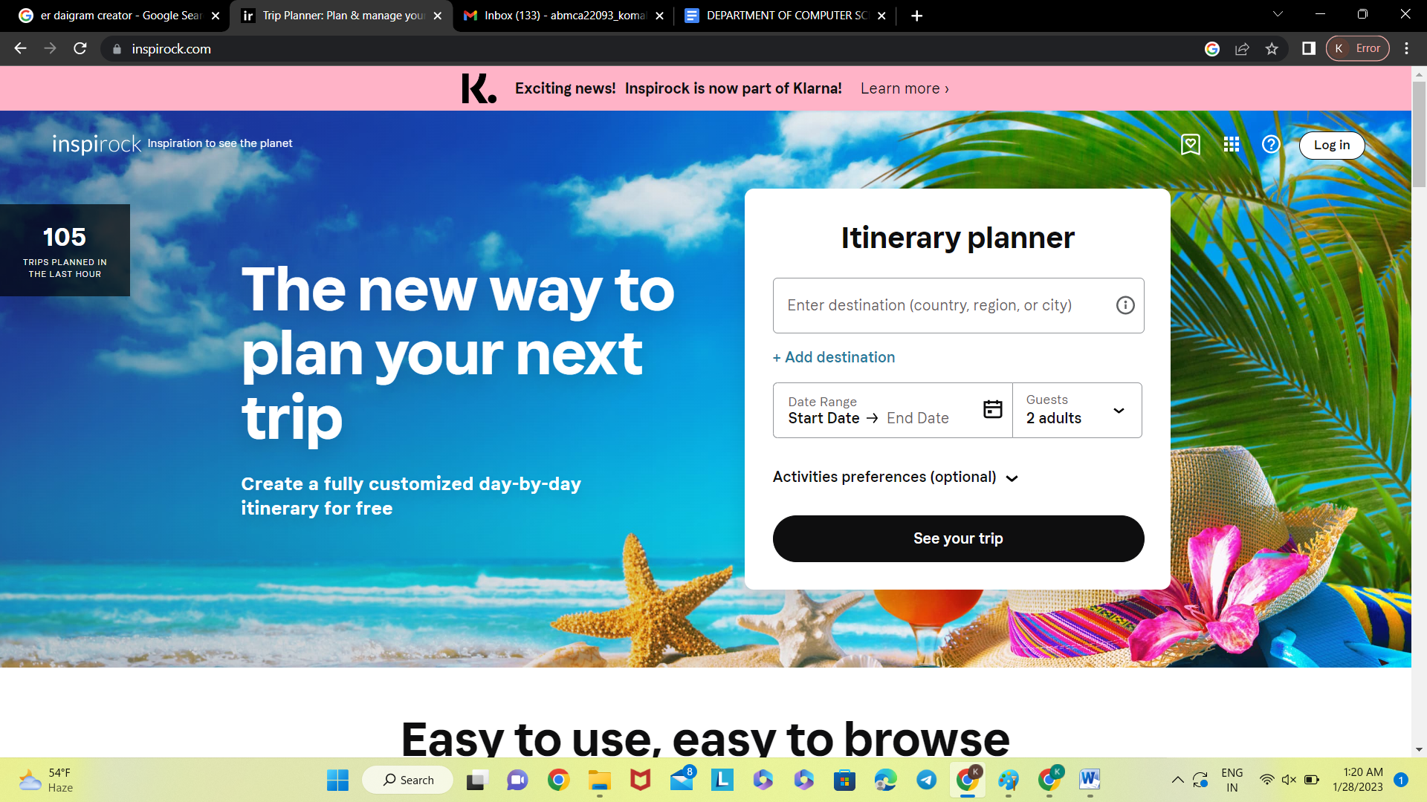

**Login page**

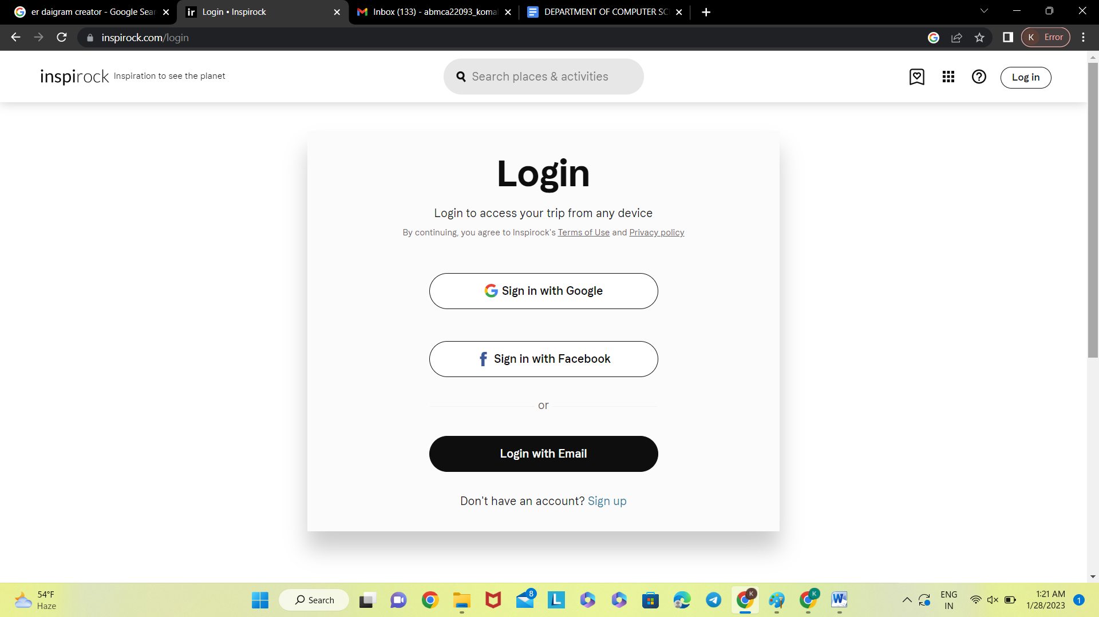

**Registration page**

